**PROBLEM STATEMENT:-**

**Merge the small files in hadoop by following the below blog.**

Here we have created a folder and the files which are to be merged are copied in the folder on hdfs. Then using the command -getmerge the files in the folder are merged.

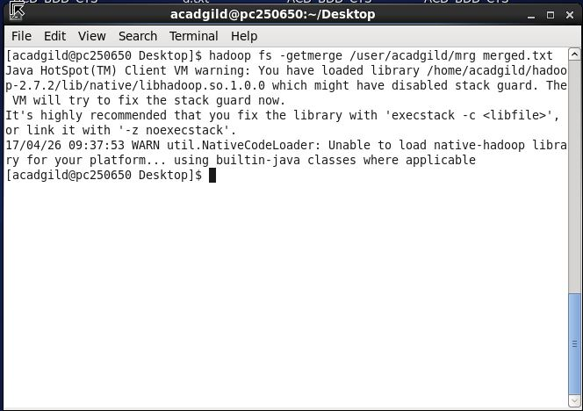

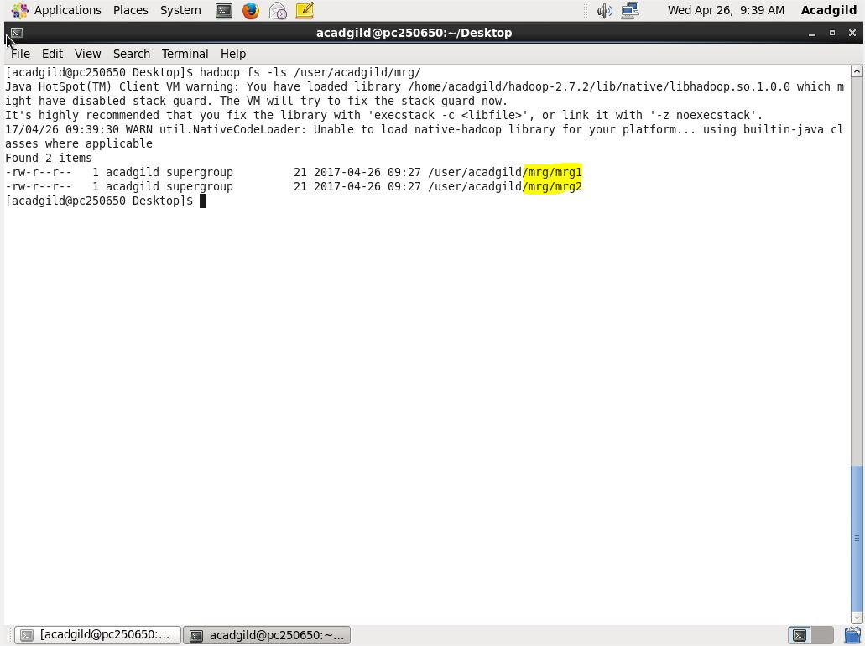

The files that are going to be merged are mrg1 and mrg2.

**OUTPUT:-**

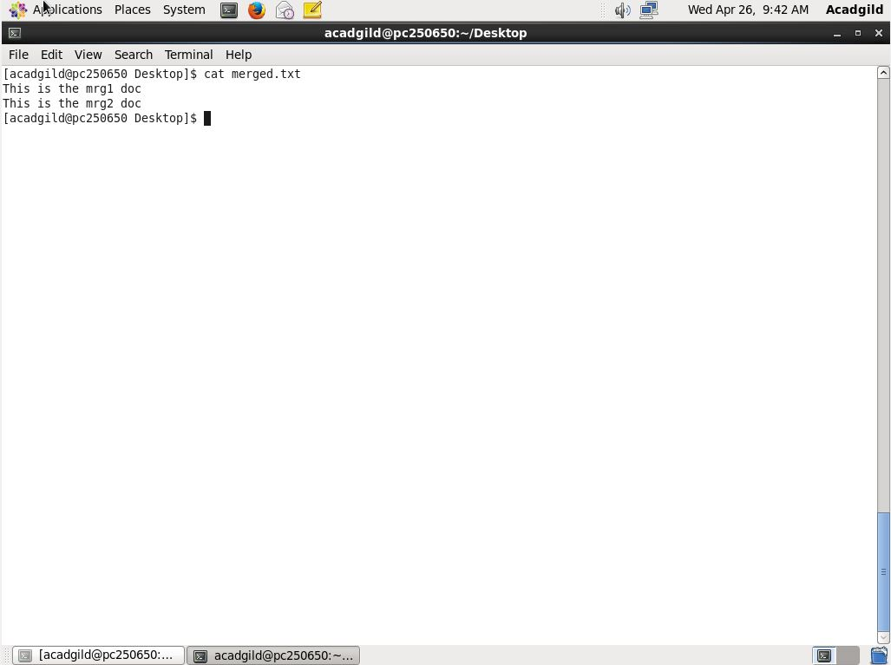

The cat command is performed on the merged.txt that we created to get the merged files mrg1 and mrg2.